# How to send emails using Azure

## Introduction

A console application that uses the [SendGrid](http://sendgrid.com) email service to send messages to multiple recipients.

Azure customers can unlock 25,000 free emails each month. These free monthly emails will give you access to advanced reporting and analytics and all APIs. See [SendGrid Features](https://sendgrid.com/features) page.

## Building the Sample

1. Start Microsoft Visual Studio 2015 and select **File > Open > Project/Solution.**
2. Go to the directory to which the sample was unzipped. Then go to the subdirectory named for the sample and double-click the Visual Studio 2015 Solution (.sln) file
3. Create a SendGrid account
   1. Log in to the [Microsoft Azure Portal](http://portal.azure.com/)
   2. Go to **New** and type “SendGrid” into the search bar
   3. Select **SendGrid Email Delivery** and click **Create**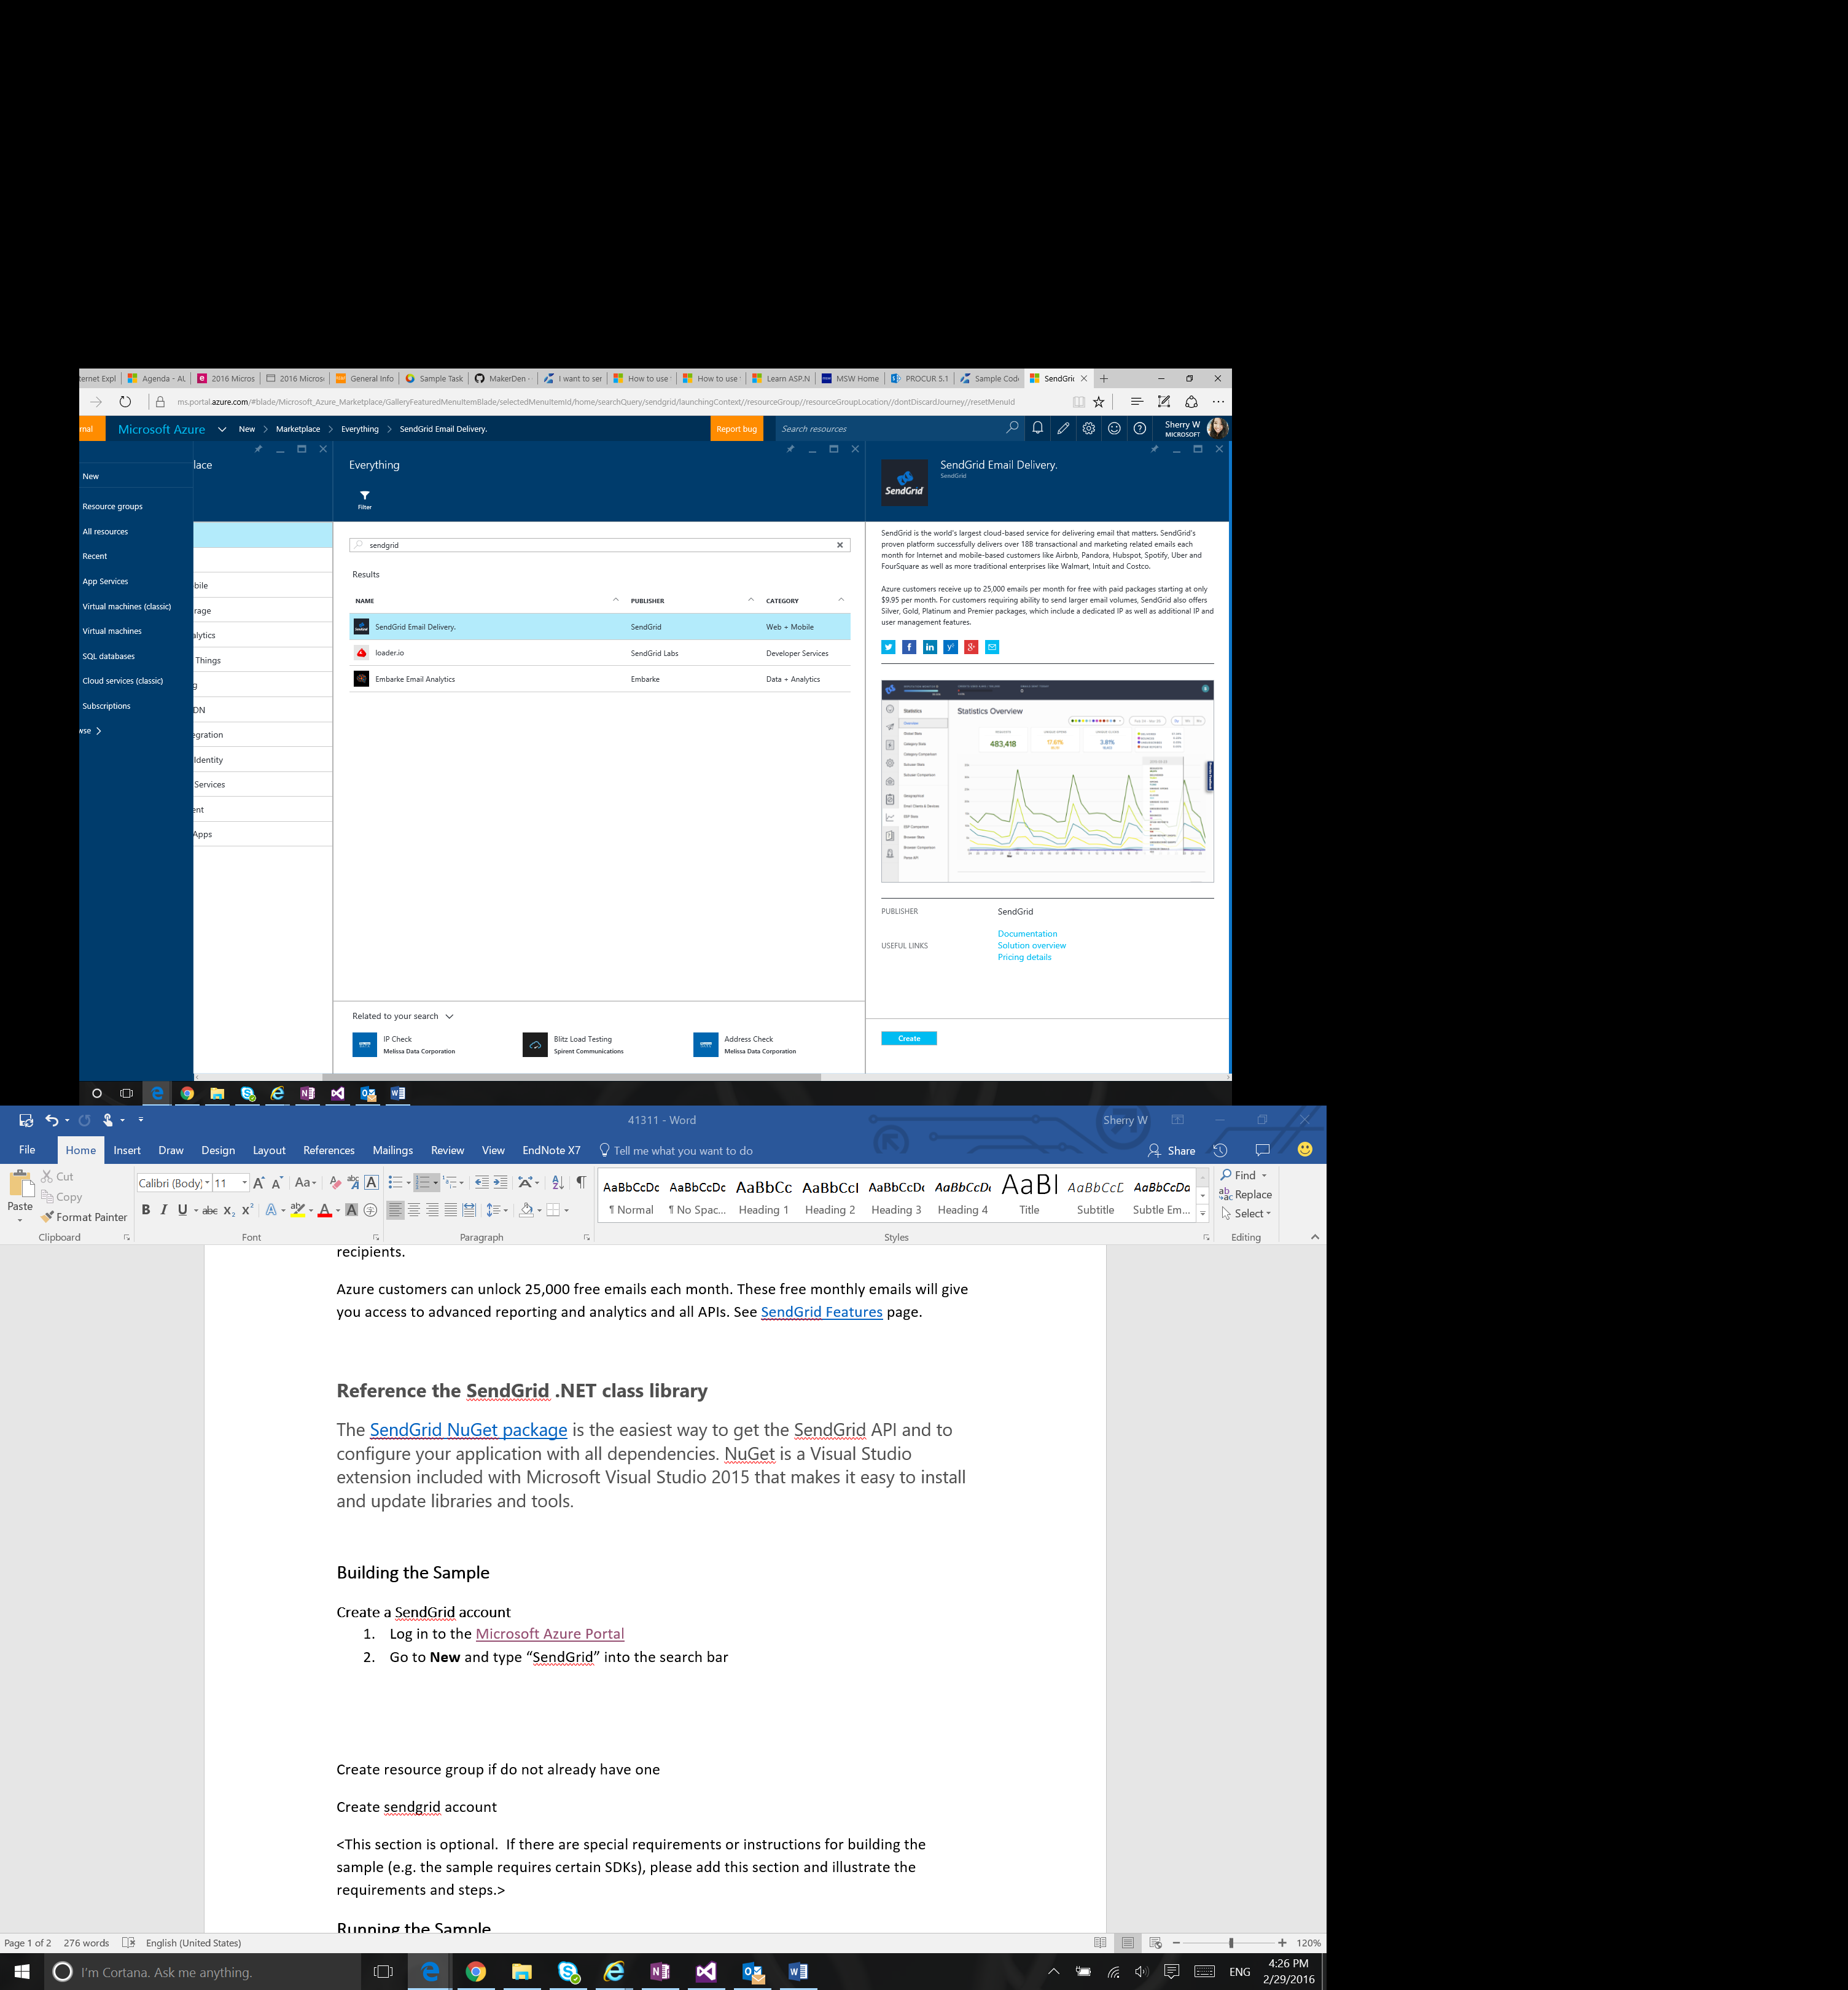
   4. Choose a name and password for your account and select an appropriate pricing tier (Azure customers can unlock 25,000 free emails each month)
4. Add your properties to the program
   1. fromProperty – email address you’d like to seen as
   2. recipientsProperty – the email addresses you’d like to receive the message
   3. subjectProperty – subject of message
   4. HTMLContentProperty – the message in HTML format
5. Enter SendGrid credentials to the program. The username and password can be found from the Azure Portal in **Keys**.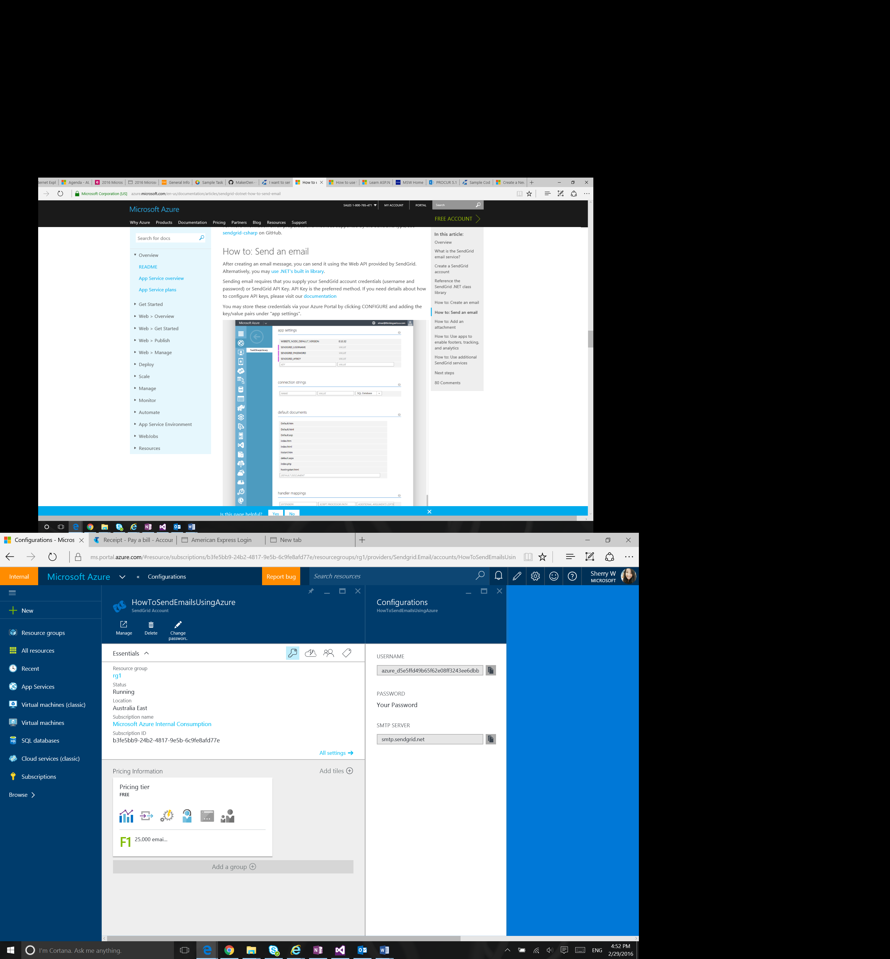

## Running the Sample

To debug the sample and then run it, press F5 or use **Debug > Start Debugging**. To run the sample without debugging, press Ctrl+F5 or use **Debug > Start Without Debugging**.

## Using the Code

Add the following code namespace declarations to the top of any C# file in which you want to programmatically access the SendGrid email service. **System.Net** and **System.Net.Mail** are .NET Framework namespaces that are included because they include types you will commonly use with the SendGrid APIs.

|  |
| --- |
| -Code block start-  --C# code snippet start--  using System;  using System.Net;  using System.Net.Mail;  using SendGrid;  --C# code snippet end--  Insert other Programming Language Code Snippet here  -Code block end- |

The code provided demonstrates how to create a simple message and add properties to it. Further properties can be added to the code and message to include attachments, footers, click tracking etc.

|  |
| --- |
| -Code block start-  --C# code snippet start--  //Message properties, add your values below  string fromProperty = "[noreply@example.com](mailto:noreply@example.com)";    List<String> recipientsProperty = new List<String>  {  @"John Smith [<john@example.com](mailto:<john@example.com)>",  @"Jane Smith [<jane@example.com](mailto:<jane@example.com)>"  };  string subjectProperty = "Title of email";  string HTMLContentProperty = "<p>Your email message in HTML format</p>";  //SendGrid credentials  string username = "Username";  string password = "Password";  //The email object  var message = new SendGridMessage();  message.From = new MailAddress(fromProperty);  message.AddTo(recipientsProperty);  message.Subject = subjectProperty;  //Add the HTML and Text bodies  message.Html = HTMLContentProperty;  var credentials = new NetworkCredential(username, password);  var transportWeb = new Web(credentials);  transportWeb.DeliverAsync(message).Wait();  --C# code snippet end--  Insert other Programming Language Code Snippet here  -Code block end- |

## More Information

SendGrid C# library repo: [sendgrid-csharp](https://github.com/sendgrid/sendgrid-csharp)

SendGrid API documentation: <https://sendgrid.com/docs>

More on using SendGrid with Azure: <https://azure.microsoft.com/en-us/documentation/articles/sendgrid-dotnet-how-to-send-email/>